Robot Manipulator Conveyor Belt Project

Description:

The goal of this project is to create a robot manipulator that sorts objects by colour sent to it using a conveyor belt. This setup is like one that may be found in an industrial setting where a robot manipulator is used to pickup objects and sort them. The major components used in this project are a four degrees of freedom robot manipulator with four revolute joints and a claw end effector, a conveyor belt made from the VEX tank robot kit, an Arduino, an Adafruit TCS34725 colour sensor, and a L298N Motor Driver.

The robot uses servo motors of varying size for its joints, an aluminum frame for its links, and is controlled by the Arduino. Each servo is (except the claw servo and the fourth joint servo) have a separate battery 6V battery pack powering them because the servo motors draw a lot of current which quickly drains the batteries of current. Therefore, by powering each servo separately, the batteries do not need to be replaced as quickly. The conveyor belt is made of VEX tank treads and two VEX DC motors from the VEX tank kit. The DC motors are controlled by the L298N Motor Driver which is controlled by the Arduino. When the Adafruit TCS34725 colour sensor detects the colour of an object in front of it, the DC motors are powered on to move the conveyor belt. The conveyor belt movement moves the object on it from in front of the colour sensor to the robot manipulator pickup location. In this project the objects that are picked up are sponges with colours red, blue, and yellow. Sponges are used as they are in a rectangular shape which fits nicely into the robot claw (end effector) and have a good texture for being picked up. Once the sponge is in the pickup location, the DC motors turn off, the robot manipulator picks up the sponge, and the robot manipulator drops the sponge in the bin associated with the sponge’s colour.

This project uses MATLAB solve the Denavit-Hartenburg parameter calculations as the DH convention is a widely used and relatively easy method for calculating the end effector of robot manipulators given the theta angles of the joints (forward kinematics) or calculating the theta angles given the end effector x, y, z, and orientation (phi) relative to the base axis (inverse kinematics). Both forward and inverse kinematics have their own methods to solving the calculations, and with the materials available to me, the geometric solution method for inverse kinematics is the only viable option (I do not have velocity calculators or encoders for the servo motors). Also, since the robot manipulator used in this project has four revolute joints and four degrees of freedom, inverse kinematics is very difficult using the geometric method, so forward kinematics was used. Examples of inverse kinematics calculations can be seen in the project with both a six degree of freedom robot and a three degrees of freedom robot in the GitHub folder.

Setup of Project:

|  |
| --- |
| Setup of robot manipulator conveyor belt project. In the top center is the robot manipulator. In the top right is the battery holders, wiring, and the Arduino. The green object at the bottom is the conveyor belt. In between the conveyor belt and robot manipulator are the bins. The bins have sponges of their assigned colour in them (left bin is for blue objects and has blue sponges in it). On the bottom right is the L298N Motor Driver and on the bottom left (the light) is the Adafruit TCS34725 colour sensor.  Note: In the code the bins are inverted from this view (ex. left bin for blue object called right bin in code) because code is from the perspective of the side of the robot manipulator. |
| Robot Manipulator |

Using map() to Adjust Real World Theta Angle to Servo Motor Angle:

The Arduino [map()](https://www.arduino.cc/reference/en/language/functions/math/map/) function is used to convert the real world theta angle (with respect to each frame’s axis) to the angle the servo motor needs to move to in order to achieve going to the real world angle [1].

|  |  |  |  |  |
| --- | --- | --- | --- | --- |
|  | Joint 1 | Joint 2 | Joint 3 | Joint 4 |
| Real World Angle | 1. 0° -> 90° 2. 0 -> -90 | 0° -> 180° | 0° -> -180° | 90° -> -90° |
| Servo Angle | 1. 90° -> 0° 2. 90° -> 180° | 0° -> 180° | 180° -> 0° | 180° -> 0° |

Wiring Diagram for Project:

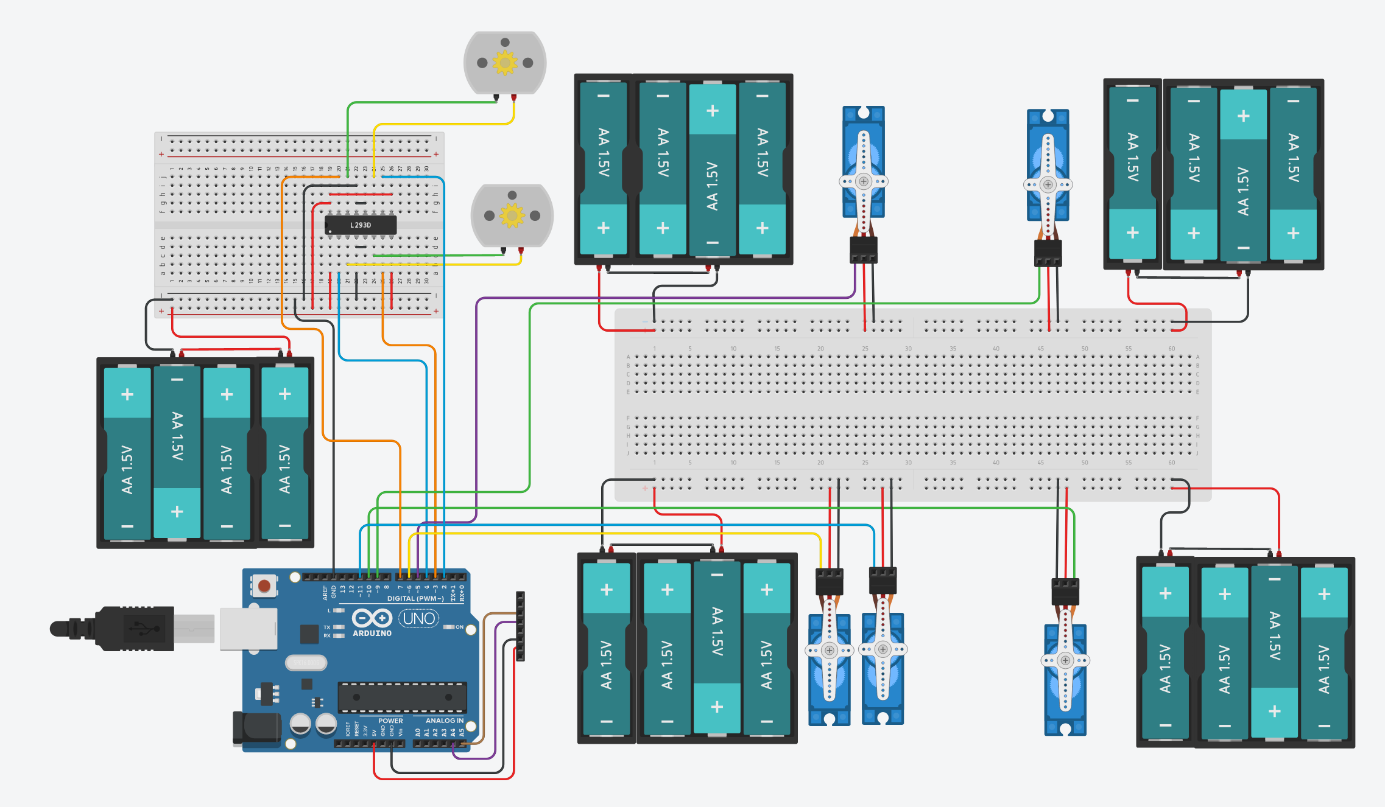

Note 1: The eight pin header is supposed to represent the wiring of the Adafruit TCS34725 colour sensor. The colour sensor is only seven pins, so the bottommost pin is ignored.

Note 2: Wiring of [L298N Motor Driver](https://create.arduino.cc/projecthub/ryanchan/how-to-use-the-l298n-motor-driver-b124c5) and [Adafruit TCS34725 colour sensor](http://arduinolearning.com/code/arduino-tcs34725-color-sensor.php) based off of wiring instructions websites [2][3].

DH Calculations:

|  |  |
| --- | --- |
| DH model of the 4 DOF robot manipulator in project [4] | |
| |  |  |  |  |  | | --- | --- | --- | --- | --- | | Link | ai | αi | di | θi | | 1 | 0 | 90° | d1 | θ1 | | 2 | a2 | 0° | 0 | θ2 | | 3 | a3 | 0° | 0 | θ3 | | 4 | a4 | 0° | 0 | θ4 | | Table of the DH parameters of the 4 DOF robot manipulator. DH parameters assigned to each link of the manipulator. Parameter ai is the displacement between the center of frame i-1 and frame i, measured in the xi axis. Parameter αi is the angle of rotating axis zi-1 to match zi, rotating around xi. To find the positive direction of αi, the right-handed rule is used. Parameter di is the displacement between the center of frame i-1 and frame i, measured in the zi-1 direction. Parameter θi is the rotation angle needed to get axis xi-1 to match with axis xi, by rotating around axis zi-1. Also, if joint i-1 is revolute, then any rotation from the revolute joint is included in θi because the rotation is around axis zi-1. |
|  | DH calculations of the transformation matrix of the robot manipulator. A transformation matrix is used to calculate the position and orientation of one frame in comparison to another frame. This transformation matrix calculates the position and orientation of frame 4 relative to frame 0.  Note: ci and si stand for cosine(i) and sine(i), respectively |
|  | The x, y, and z position of frame 4 relative to frame 0. These values correspond to the first three values of the transformation matrix’s fourth column (from top of the matrix to the bottom).  Note 1: cij and sij stand for cosine(i +j) and sine(i + j), respectively  Note 2: cijk and sijk stand for cosine(i +j + k) and sine(i + j + k), respectively |

MATLAB Code:

|  |  |
| --- | --- |
|  | Lengths of the links for the robot manipulator in centimeters. |
|  | Input of the theta angles for the Denavit-Hartenbug forward kinematics. Theta angles inputted in degrees and are converted to radians in MATLAB. |
|  | End effector x, y, and z coordinates of the robot manipulator. Equations are determined from the fourth column of the transformation matrix. |
|  | End effector angle of the robot manipulator (called phi in this calculation). Phi determined from adding the theta angles of all the joints and is in degrees. |
|  | Displays the output of the robot manipulator’s end effector x, y, z, and phi positions in the command window. |

Arduino Code:

|  |  |
| --- | --- |
|  | <Servo.h> is used to allow the Arduino to control the servo motors of the robot manipulator. <Wire.h> is used to allow the Arduino to communicate with the TCS34725 colour sensor. “Adafruit_TCS34725.h” implements the functions needed to calculate the input readings of the TCS34725 colour sensor. |
|  | Creates servo objects for each of the robot manipulator’s joints and the end effector claw. Each joint of the robot manipulator is a servo motor, and the claw end effector is opened and closed using a servo motor. |
|  | Variables for each joint’s theta value. Since the theta values are variable, the variables are not constant. Theta 3 and 4 use the map() function to adjust the real theta values to the angle of the servo for the Arduino (ex. If the real world angle is -65° and the joint can range between 0° and -90° while the Arduino has this angle between 180° and 90°, map() changes -65° to 115°). |
|  | Variables for the open and closed servo degrees. Variables for the initial (home) position (in degrees) for the servo motors of joints 1 and 2. All these variables are constant because they do not change. |
|  | Variables for counting how many times the colour sensor has detected a colour in succession. These colour counter variables are used to determine a more accurate reading of an object’s colour since the colour sensor can detect a wrong colour under conditions like when positioning the object in front of it. |
|  | Pins on the Arduino that are connected to the DC motors of the conveyor belt. Each DC motor uses two pins on the Arduino, hence there are two variables for each DC motor. The pins on the Arduino that are connected to the conveyor belt DC motors do not changed so the variables are constant. |
|  | Setup of code. Allows serial output, attaches the pins of the Arduino to the servos, sets the robot arm to the initial (home) position, opens the claw end effector, attaches the pins of the Arduino to the conveyor belt DC motors, and checks if the colour sensor is attached. |
|  | The initial functions of the looped code are for the colour sensor to get the red, blue, green, and clear colour readings and then to set the robot manipulator to its initial position. The colour reading is put first because the rest of the looped code using conditional statements that rely on the colour reading. The robot manipulator is brought to its initial position to ensure it is in a known position at the beginning of every loop. This prevents unforeseen paths of the robot manipulator from occurring. Code snippet used for the project is from how to use an Adafruit TCS34725 colour sensor and an Arduino [3]. |
|  | If-else statement to check if 80% of the highest colour value is greater than the full value of the second highest colour value. This is used to determine what colour the object is. Only red and blue are compared because these are always the two highest colour values with the sponge objects used. |
|  | If the red, green, and blue values are less than 600, 400, and 450, respectively, than an object is not in front of the colour sensor. These values were found through testing using the Colour_Sensor_and_Conveyor_Belt_Setup Arduino file by putting objects in front of the colour sensor and seeing the range of values of the red, blue, and green colours. If no object is detected than each colour’s counter is reset, the serial output is “Nothing”, and the conveyor belt is stopped. |
|  | A red object has been detected if 75% of the red value is greater than the green and blue values. The red counter is then incremented while the blue and green counters are reset. If a red object has been detected twice (or more) in a row then “Red” is outputted serially, the object is moved from in front of the colour sensor to the pickup area, the robot manipulator picks up the object, and the robot manipulator drops the object in the left (red) bin. An identical pattern is followed when a blue or yellow object is detected. |
|  | Function used to put the robot manipulator into the initial (home) position. The joints have theta angles 0°, 90°, -65°, and 25°, respectively. The end effector x, y, z, and rotation (phi) are 20.1961, 0, 36.6791, and 50°, respectively. This displacement and rotation are used as the initial position because it a distinct location that from visual inspection will not be confused with another position and in this position the robot manipulator is far enough away from the conveyor belt and bins, so it will not hit them when moving to this position. The for loops are used to stop the movement of their respective joint earlier than the desired final position. This ensures the robot manipulator avoids hitting another object and has a smooth approach to the desired final position. Without the for loops the robot manipulator creates a large force when moving and hits the conveyor belt during pickup. |
|  | The pickup function sends commands to the joints to have the claw end effector go to the location of the pickup location of the objects on the conveyor belt. Each joint’s real world theta angle then changes to θ1 = 0°, θ2 = 50°, θ3 = -65°, and θ4 = 25°. The end effector’s position is x = 37.2494, y = 0, z = 9.8918 while its orientation is phi = 0°. As explained in the initial_positon() function, the for loop stops joint 2 early and then slowly moves joint 2 to the desired angle to ensure the robot manipulator will not hit the conveyor belt when it is picking up an object. The claw then closes to grasp the object. The delays allow an adequate amount of time to stop the servo motors that move the joints and then pick up the object in two distinct actions (rather than the two actions overlapping). |
|  | Function that drops the object in the right (blue) bin. Robot manipulator goes to the initial position at start of function. Each joint’s real world theta angle then changes to θ1 = -45°, θ2 = 68°, θ3 = -110°, and θ4 = 46°. With these joint angles, the x, y, z, and phi angles are x = 20.9520, y = 20.9520, z = 10.2992, and phi = 4°. Phi is 4° so that z can be 10cm. The claw then opens to drop the object into the bin. The delays are one second each as they give the robot manipulator enough time to move the joints and then drop the object in a distinct manner from each other. |
|  | Function that drops the object in the left (red) bin. Robot manipulator goes to the initial position at start of function. Each joint’s real world theta angle then changes to θ1 = 40°, θ2 = 70°, θ3 = -80°, and θ4 = -35°. With these joint angles, the x, y, z, and phi angles are x = 20.9682, y = 17.5944, z = 7.2284, and phi = -45°. The claw then opens to drop the object into the bin. The delays are one second each as they give the robot manipulator enough time to move the joints and then drop the object in a distinct manner from each other. The delay in the for loop allows enough time to pause each joint movement so it does not create a large force. |
|  | Function that drops the object in the center (yellow) bin. Robot manipulator goes to the initial position at start of function. Each joint’s real world theta angle then changes to θ1 = 0°, θ2 = 100°, θ3 = -90°, and θ4 = -55°. With these joint angles, the x, y, z, and phi angles are x = 19.3792, y = 0, z = 12.0952, and phi = 45°. The claw then opens to drop the object into the bin. The delays are one second each as they give the robot manipulator enough time to move the joints and then drop the object in a distinct manner from each other. |
|  | Function that runs the conveyor belt’s DC motors. The delay value of 3.45 seconds allows the DC motors to stay on long enough for the object to travel from in front of the colour sensor to the pickup location of the robot manipulator. Code snippet used for the project is from how to power up a DC motor with the L298N Motor Driver and an Arduino [2]. |
|  | Function that stops the conveyor belt’s DC motors. Delay for 100 milliseconds keeps each loop of the code as short as possible while still turning off the DC motors. Code snippet used for the project is from how to power up a DC motor with the L298N Motor Driver and an Arduino [2]. |

**References**

[1] “map(),” *map() - Arduino Reference*. [Online]. Available: https://www.arduino.cc/reference/en/language/functions/math/map/. [Accessed: 05-May-2021].

[2] R. Chan, “How to use the L298N Motor Driver,” *Arduino Project Hub*. [Online]. Available: https://create.arduino.cc/projecthub/ryanchan/how-to-use-the-l298n-motor-driver-b124c5. [Accessed: 05-May-2021].

[3] shedboy71, “Arduino and TCS34725 Color Sensor,” *Arduino Learning*, 26-Nov-2017. [Online]. Available: http://arduinolearning.com/code/arduino-tcs34725-color-sensor.php. [Accessed: 05-May-2021].

[4] T. Lens, J. Kunz, and O. von Stryk, “Dynamic Modeling of the 4 DoF BioRob Series Elastic Robot Arm for Simulation and Control,” *Simulation, Modeling, and Programming for Autonomous Robots*, pp. 411–422, 2010.